Activity – 02

Ganesh Gundekarla

11700551

Question 1 : database creation :

This is done by :

create database CompanyDB;

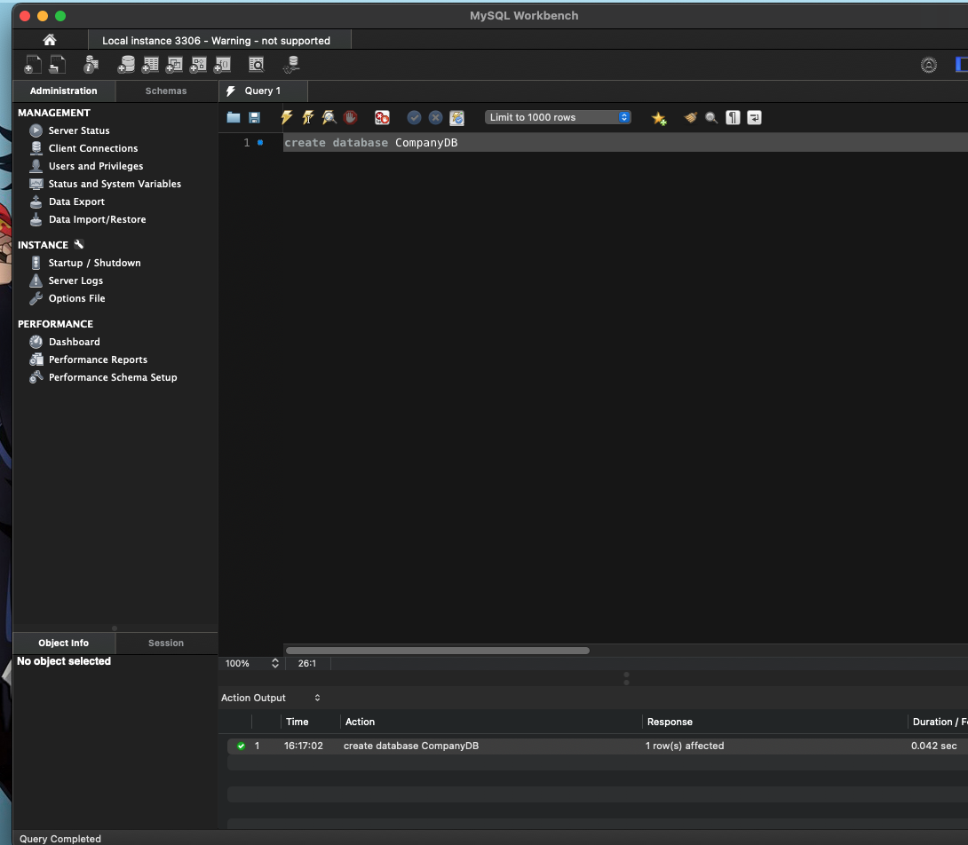

Question 02 : creation of table

Two tables are being created next , one is for Employees and one is for Salaries.

1. create table Employees (

emp_id INT primary key,

emp_name VARCHAR(50),

department VARCHAR(30)

);

Now we create another table which is named Salaries which has the attributes of id and monthly salary .

1. create table Salaries(

emp_id INT,

monthly_salary DECIMAL(10,2),

Foreign key(emp_id) references Employees(emp_id)

);

Question 03

Insertion of data into create tables .

Firstly , we are going to insert the employee details into the Employees table and the salaries of the respected persons in the Salaries table.

1. Inserting data into Employees.

insert into Employees(emp_id,emp_name,department)values

(1,'John Doe','HR'),

(2,'Jane Smith','IT'),

(3,'Bob Johnson','Finance');

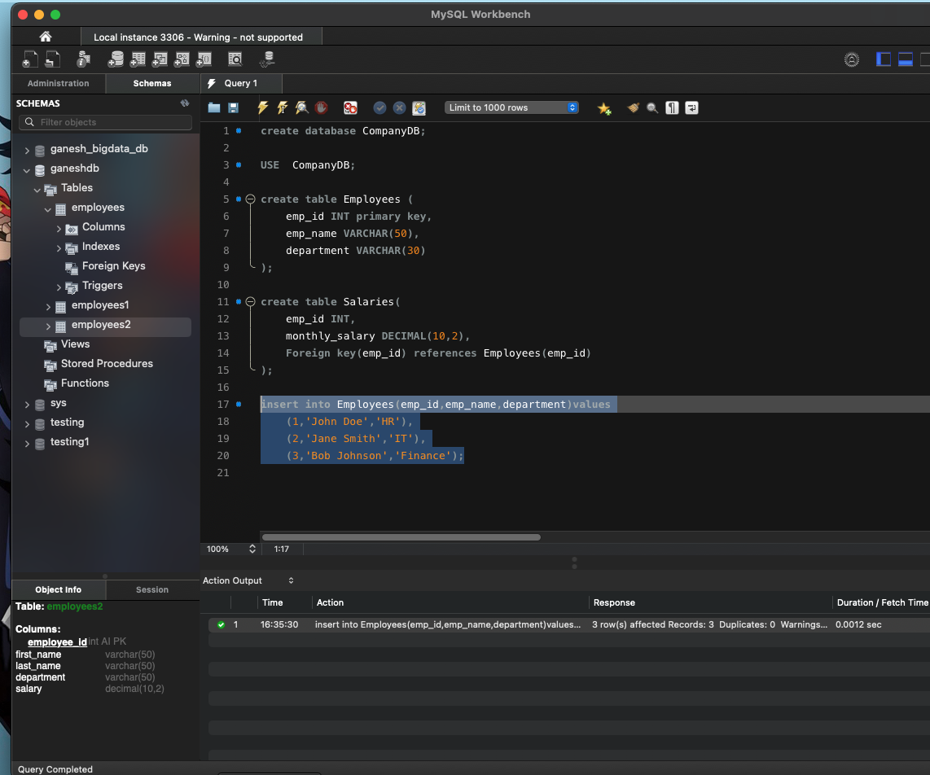

1. Insertion done into salaries table .

insert into Salaries(emp_id,monthly_salary)values

(1,5000.00),

(2,6000.00),

(3,5500.00);

Question 04

1. Here , select * is used to basically retrieve everything from the table.

select * from Employees;

1. We can select a specific column column using SELECT and FROM and also we can provide a condition along with it using WHERE .

select monthly_salary from Salaries;

Question 05

Using joins .

1. Here , combining of the data can be done using Employees and Salaries using the ‘inner join’. So we get the result in one table showing both tables .

select * from Employees inner join Salaries ON Employees.emp_id=Salaries.emp_id;

1. All the employees with their salaries can be listed using the left join method.

select * from Employees left join Salaries on Employees.emp_id=Salaries.emp_id;

Question 06

1. WE can perform avg of monthly salaries using an inbuilt method in sql

Avg(column_name) provides us with the avg salary of the employees.

select avg(monthly_salary) as average_salary from Salaries;

1. Total number of employees.

, it provides you a number of how many employees each are in each department of the company with branch .

select department,count(emp_id) as total_employees from Employees group by department;

Question 07

1. Add a unique value

The term unique prevents duplicates to the emp_id in the table”Employees”, so if you are beginning to inset a new row with an emp_id which is already in existance in the table , it provides us error , useful for data integrity .

alter table Employees add constraint unq_val_emp_id unique(emp_id);

Question – 08

1. So , the employee table employee can be changed his department from anything to ‘IT ‘ can be done using ‘UPDATE ‘ and followed by a condition using ‘WHERE ‘ .

update Employees set Department='IT' where emp_id=1;

Here , we update employees in department where employee id is ‘1’ to IT .

1. Same monthly salary is done using the ‘update ‘ command.

update Salaries set monthly_salary=6500 where emp_id=2;

Question – 09

1. Delete of a row can be done using delete command .

delete from Employees where emp_id=2;

we are deleting from employees table , a row with emp_id=2 is being deleted now.

We cannot process it

Reason : Since we had deleted a row existing in the Employee table where the id=2 , because of the foreign key set to emp_id , we cannot be able to delete it directly .

This can be done using removing first from salaries then removing it from employees.

Question 10.

Differences between DELETE , DROP , TRUNCATE

1. DELETE.
2. Here , the delete in sql is used in order to remove rows one or two from table by a set of conditions followed after delete .
3. This is used to manipulate the table.
4. This is considered to be slow than the truncate command if you are opting on large tables , the reason lies in logs in individual rows are being deleted at a time .

Example . Delete from GaneshDB where expenses=’one dollar’;

This deletes from the database ganeshDB , and the expenses with one dollar , all the rows are being deleted .

1. Drop
2. This is used to remove an entire table or a database .
3. This thing cannot be rewinded back.
4. This removes tables or database entirely with all its index,permissions.
5. Syntax : DROP table table_name;

Ex: drop table ganeshDB ;

This removes the table ganeshDB from the database

1. Truncate
2. The truncate command is used to preserve the table in the database but to remove all the rows in the existing table .
3. It’s a data definition language one .
4. This thing cannot be taken back.
5. Faster compared to delete .
6. Ex : truncate table ganeshDB;

Unlike drop the table will be still be present but all row are deleted here .